Operating System Week 12-13

Name : Tanishq Vyas
SRN : PES1201800125
Section : H
Semester : 5
Branch : CSE

1. Dining Philosopher

Used the basic concept of reversing the order of last Philosopher’s order of picking chopsticks. Thus avoiding the circular wait condition. Thus preventing the deadlock with the elimination of circular wait and usage of binary semaphore.

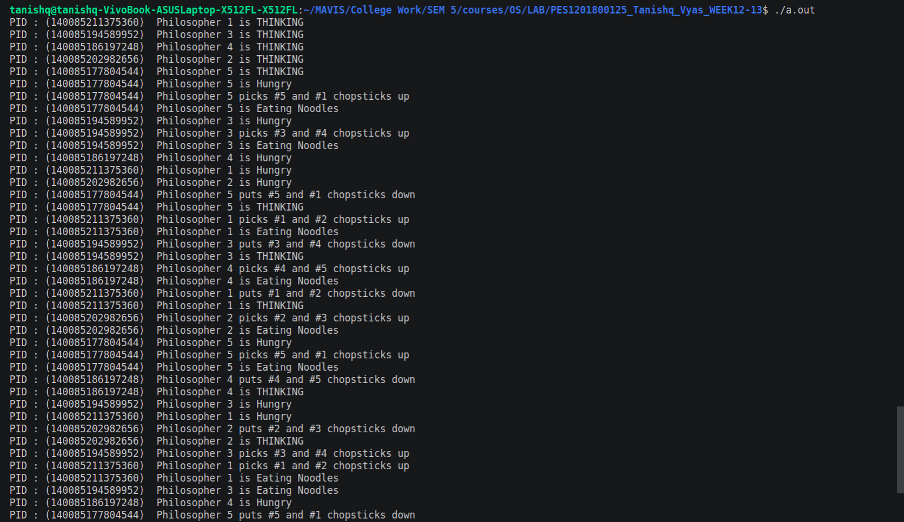
Fig : Execution for Dining Philosopher

2. FCFS Disk Schedueling

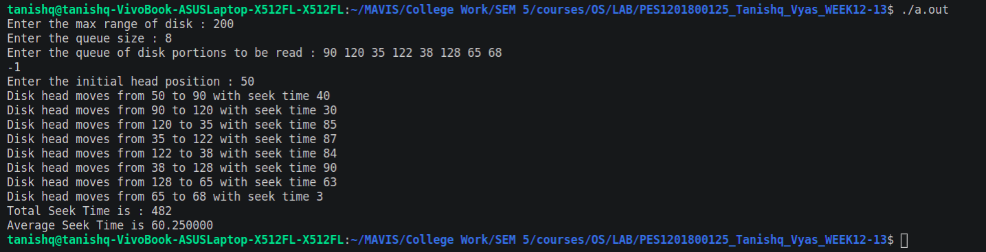

Fig : Execution for FCFS Disk Schedueling

